**Vision and Mission of the Computer Science and Engineering**

**(Data Science)**

**Vision**

To provide a quality and holistic education in data science, data analytics, data visualization, industry collaborations and research for empowering individuals to derive knowledge, thereby transform the potentials in data for the betterment of society.

**Mission**

|  |  |
| --- | --- |
| 1 | Educate and prepare students with a strong foundation in data science, equipping them with the skills, knowledge, and ethical principles needed to excel in  data-driven fields. |
| 2 | Foster collaborations with industries to adopt modern data science and visualization tools which solves the real-world problems that have societal benefits. |
| 3 | Cultivate a culture of life-long learning with intellectual curiosity in data science and nurturing individuals who are passionate about data-driven decision-making |

**Program Educational Objectives (PEOs)**

|  |  |
| --- | --- |
| 1 | Graduates will work in the area of applications of software development, Artificial Intelligence, Machine Learning, Data Analytics and Data Visualization. |
| 2 | Graduate will exhibit professional ethics and moral value with capabilities of working as an individual and as a team member in the corporate world to contribute toward the need of the dynamic requirements of industry and society. |
| 3 | Graduates will become responsible successful software professionals with leadership and managerial quality in the modern software industries based on their strong skills on theoretical and practical foundation. |

**Course objectives:**

|  |  |
| --- | --- |
| 1 | To Provide a strong foundation in database concepts, technology, and practice. |
| 2 | To Practice SQL programming through a variety of database problems. |
| 3 | To Understand the relational database design principles. |
| 4 | To Demonstrate the use of concurrency and transactions in database. |
| 5 | To Design and build database applications for real world problems. |
| 6 | To become familiar with database storage structures and access techniques. |

**Course outcomes (Course Skill Set):**

At the end of the course, the student will be able to:

|  |  |
| --- | --- |
| 1 | Describe the basic elements of a relational database management system |
| 2 | Design entity relationship for the given scenario. |
| 3 | Apply various Structured Query Language (SQL) statements for database manipulation. |
| 4 | Analyse various normalization forms for the given application. |
| 5 | Develop database applications for the given real-world problem |
| 6 | Understand the concepts related to NoSQL databases. |

**CONTENTS**

**ABBREVIATION**

**Chapter 1: Introduction**

* 1. DESCRIPTION
  2. PROBLEM STATEMENT
  3. PURPOSE SYSTEM
  4. OBJECTIVES

**CHAPTER 2: LITRETURE SURVEY**

* 1. Overview of Existing Research

2.2 DESCRIPTION OF LANGUAGE USED

**CHAPTER 3: SYSTEM REQUIREMENTS**

3.1 FUNCTIONAL REQUIREMENTS

3.2 NON-FUNTIONAL REQUIREMENTS

3.3 HARDWARE REQUIREMENT

3.4SOFTWARE REQUIREMENT

3.5 ENTITY – RELATIONSHIP DIAGRAM

**CHAPTER 4: SCREENSHOTS**

**CONCLUSION**

**ABSTRACT**

The **Medicine Inventory Management System** is a computer program created to counter the essential challenges faced in the handling of drugs within healthcare facilities like hospitals, clinics, and pharmacies. Due to the increase in the volume of drugs on the market, monitoring their quantity and shelf life has become quite cumbersome. Most healthcare providers continue to use pen-and-paper systems or simple spreadsheets to keep track of their inventory, which ends up creating inefficiencies, expired stock, and the inability to have critical medicines available during critical points. The system proposed here plans to automate the entire process of inventory management through the implementation of a central platform that keeps all the medicine information in real time.

**ABBREVIATIONS**

DBMS Database management system

SQL Structure query language

PHP Hypertext preprocessor

HTML Hypertext markup language

CSS Cascading style sheet

ER diagram Entity relationship diagram

**CHAPTER 1**

**1.1 INTRODUCTION**

In the medical field, access to medicines directly correlates with the health of patients and the outcome of treatment. Proper medicine inventory management is critical to ensure that required drugs are in stock when needed and potentially toxic medicines are taken out of circulation. Yet, keeping a large inventory of products—each with its own batch numbers, expiration dates, and storage needs—is a huge challenge. The traditional practices, e.g., manual registers or spreadsheets, are widely practiced but are extremely inefficient for contemporary healthcare needs.

To overcome these issues, the **Medicine Inventory Management System** is presented as an integrated digital solution. It streamlines the essential processes of pharmaceutical inventory management, such as adding new stock, monitoring current levels of stock. The system minimizes dependence on human memory and manual verification by sending automatic reminders when stock is low.

**1.2. DATABASE MANAGEMENT SYSTEM**

A Database Management System (DBMS) is software that enables users to efficiently define, create, manage, and control access to databases. It serves as an interface between end users and databases, ensuring that data is consistently organized and easily accessible. DBMS plays a critical role in modern applications by supporting data storage, retrieval, manipulation, and security.

As the volume and complexity of data continue to grow in various domains—such as business, healthcare, education, and e-commerce—the need for robust and scalable data management systems becomes increasingly essential. A DBMS allows multiple users to interact with the data concurrently while maintaining data integrity and minimizing redundancy. It also supports advanced functionalities such as data querying, indexing, transaction management, and backup and recovery mechanisms.

In essence, a DBMS streamlines data handling processes, improves decision-making through accurate data access, and enhances data consistency and security. Its structured environment forms the backbone of many software systems and enterprise applications, enabling organizations to manage and utilize data as a valuable resource.

**1.3 PROBLEM STATEMENT**

develop a web-based interface for a Medicine Inventory Management System that simplifies CRUD operations, improves accuracy, and enhances the overall management of pharmaceutical inventory.

**1.4 PURPOSE SYSTEM**

A Medicine Inventory Management System (MIMS) is software that helps monitor the movement, storage, and distribution of pharmaceutical products in a healthcare organization. It ensures safe handling and management of medicines so that patients receive the right care and the organization operates effectively.

**Main Functions of a Medicine Inventory Management Information System**

1. **Tracking Inventory in Real Time**

Stock control at MIMS is done in real time by utilizing barcode scanning and RFID technologies. Stock visibility reduces stockout and overstocking incidents. Medications will be available at the time of need without excess.

1. **Compliance to Regulations and Reporting**

MIMS assists health care facilities in meeting Non-therapeutic Expenditure (NTE) regulations by maintaining accurate records of medication usage, documenting controlled substances, and providing reports needed for audits and inspections.

1. **Optimize Costs and Use Resources Effectively**

With the help of MIMS, health care facilities are able to eliminate wasteful resource expenditure by understanding usage rates.

1. **Resource Allocation and Cost Efficiency**

MIMS provides the healthcare industry with analytics that assist in streamlining spending and purchasing by their usage trends and inventory turnover accuracy. This, in turn, allows for better resource allocation and reduction in wasteful spending.

1. **Improved Patient Safety and Care Quality**

Proper medication inventory management directly translates to having the medications ready when they are needed by the patients, thereby minimizing errors and increasing the standard of care provide.

As highlighted above, a Medicine Inventory Management System (MIMS) is a powerful asset to any healthcare institution, as it simplifies medication processes, assures compliance with applicable laws and regulations, aids in achieving better health outcomes, and supports overall organizational efficiency.

**1.5 OBJECTIVES**

**Objectives of a Medicine Inventory Management System**

The objective of the Medicine Inventory Management System is to design and develop a web-based application that efficiently manages the inventory of medicines in pharmacies or healthcare facilities. The system aims to simplify the process of adding, viewing, updating, and deleting medicine records (CRUD operations), while ensuring accuracy, transparency, and real-time tracking of stock levels. It also seeks to minimize human errors, reduce medicine wastage due to expiration or overstocking, and enhance decision-making in inventory control. Ultimately, the system supports better resource management and ensures the availability of essential medicines when needed**.**

**CHAPTER 2**

**LITERATURE SURVEY**

**2.1. Overview of Existing Research**

Different researchers have looked into medicine inventory systems to address inefficiency in healthcare supply chains. For instance, Gupta et al. (2019) established an automated drug inventory system for hospitals based on barcode scanning. Their system greatly enhanced stock management by minimizing the use of expired medicines and timely restocking. Another research by Rahman and Ahmed (2020) proposed an IoT-based system that employed RFID tags and sensors to facilitate real-time monitoring and tracking of drug stock. Their research focused on automation to reduce human error and delays. These researches indicate that the integration of technology in medicine inventory management improves accuracy, efficiency, and cost savings. By tapping into key areas such as expiry tracking and stock optimization, these systems enable healthcare providers to prevent waste while ensuring dependable access to critical drugs. The recurring theme in this study is the imperative of automating medicine inventory systems in order to eliminate manual reliance and enhance patient safety and quality of service.

**2.2** **DESCRIPTION OF LANGUAGES**

**1. HTML (Hyper Text Markup Language):**  
HTML is the standard markup language used to create the structure and layout of web pages. In this project, HTML is used to design the front-end interface, including forms for adding, updating, and viewing medicine records. It defines elements like input fields, buttons, tables, and navigation menus, ensuring a user-friendly and organized interface.

**2. PHP (Hypertext Preprocessor):**  
PHP is a server-side scripting language used to handle the backend logic of the application. In the Medicine Inventory Management System, PHP is responsible for processing form data, interacting with the database, performing CRUD operations, handling user sessions, and ensuring dynamic content rendering.

**3. SQL (Structured Query Language):**  
SQL is used to manage and manipulate the data stored in the database. It handles queries for creating tables, inserting new medicine records, updating stock levels, retrieving inventory data, and deleting outdated entries. SQL ensures that data is accurately stored, retrieved, and maintained in a relational database such as MySQL.

**CHAPTER 3**

**SYSTEM REQUIREMENTS**

**3.1 FUNCTIONAL REQUIREMENTS**

These state what the system must do

1. **User Authentication and Roles**

* Admin login
* Pharmacist login
* Role-based access control

**2. Inventory Management**

* Add, edit, delete medicine records
* Track stock levels
* Auto-update stock on sales/purchase
* Low stock alerts

**3.Medicine Details Management**

* Store drug name, type, price, etc.
* Barcode integration.

**4. Sales and Billing**

* Create bills for customers
* Add discounts and taxes
* Print or send invoice via email

**3.2 NON-FUNCTIONAL REQUIREMENTS**

These determine the quality features of the system,

1. **Usability**  
    User-friendly interface for non-technical users
2. **Performance**  
   Quick response time for big inventory   
   Optimized search process
3. **Reliability**  
   System to operate 24/7 with minimal down-time
4. **Security**

Role-based access  
Password encryption  
Audit logs

1. **Scalability**  
   Ability to support additional branches or users in the future
2. **Maintainability**  
   Simple to update or correct bugs.

**3.3 HARDWARE REQUIREMENTS**

* **Processor**: Intel i5 or higher
* **RAM**: 8 GB or more
* **Storage**: 256 GB SSD or higher
* **Display**: 1080p monitor
* **Printer**: For invoice printing
* **Barcode**: Scanner

**3.4 SOFTWARE REQUIREMENTS**

* **Operating System**: Windows 10/11 or Linux (Ubuntu)
* **Database**: MySQL / PostgreSQL / SQLite
* **Backend**: PHP / Java / Python / Node.js
* **Frontend**: HTML, CSS, JavaScript
* **Web Server**: Apache / XAMP/WAMP
* **Browser**: Chrome / Firefox (for web-based systems)

**3.5 ENTITY-RELATIONSHIP DIAGRAM:**

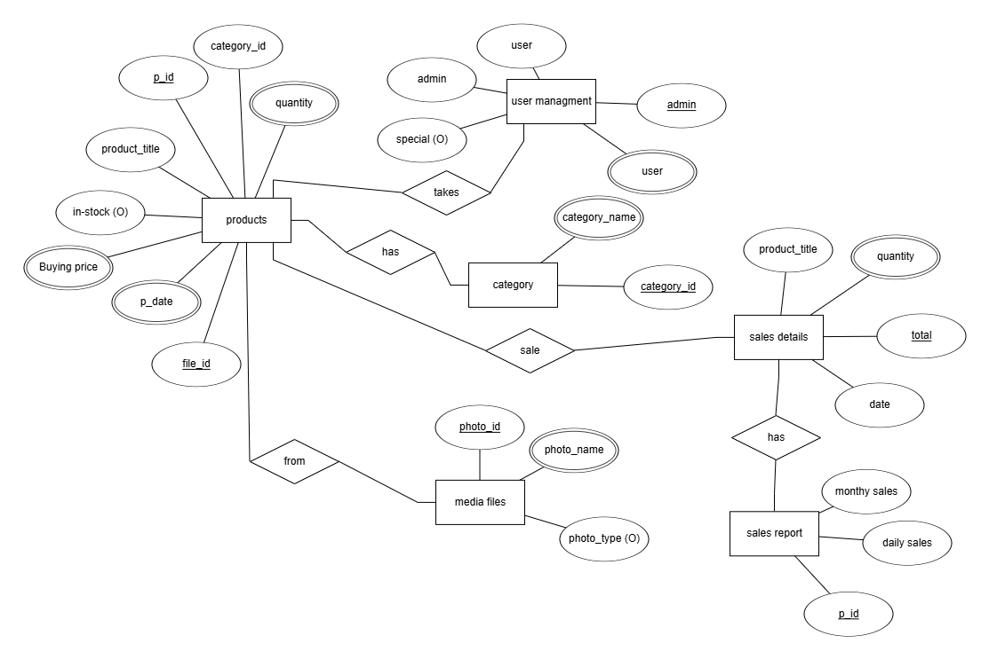

FIG 4.1: Medicine inventory management system ER diagram

**4. SCREENSHOTS**

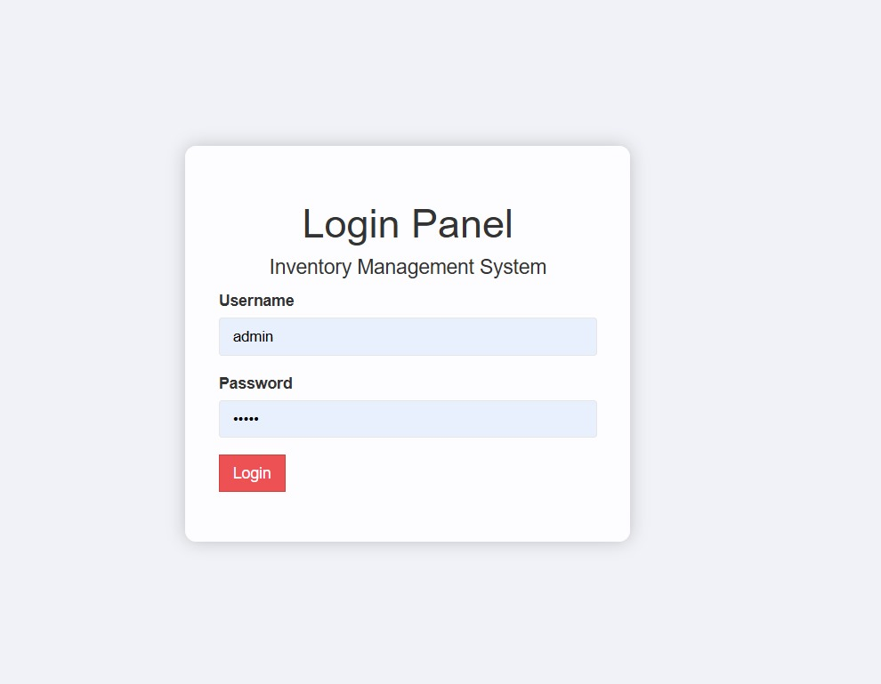

Fig 4.2 Login Page: Username – admin, Password- admin

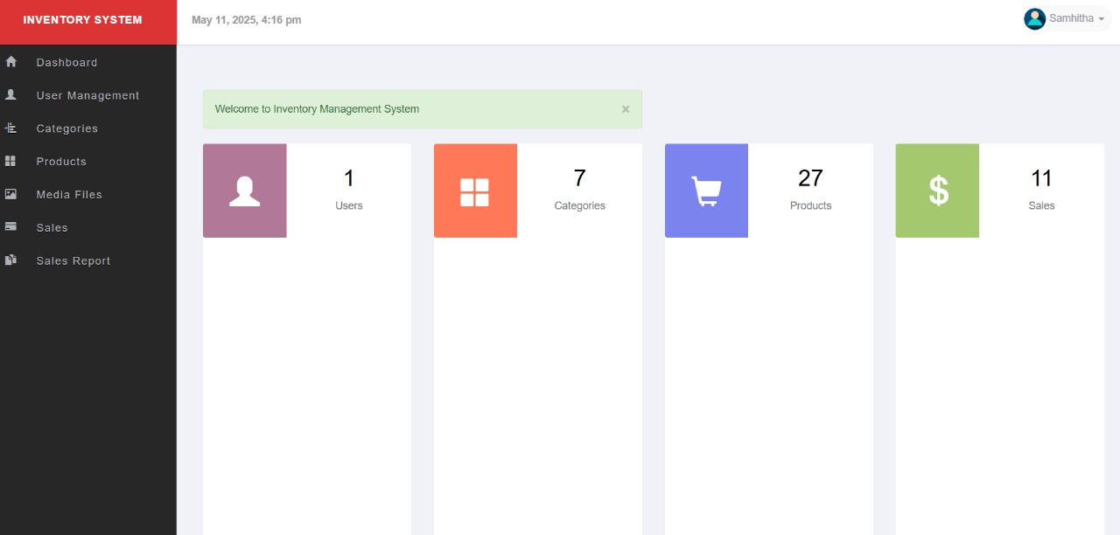

Fig 4.3: Home Page with Dashboard

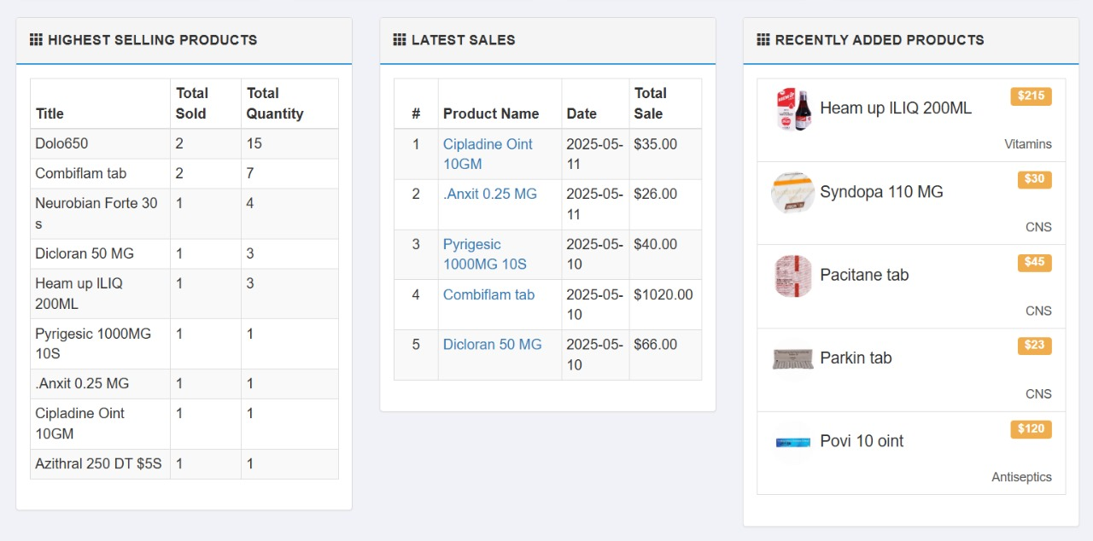

Fig 4.4: Home Page

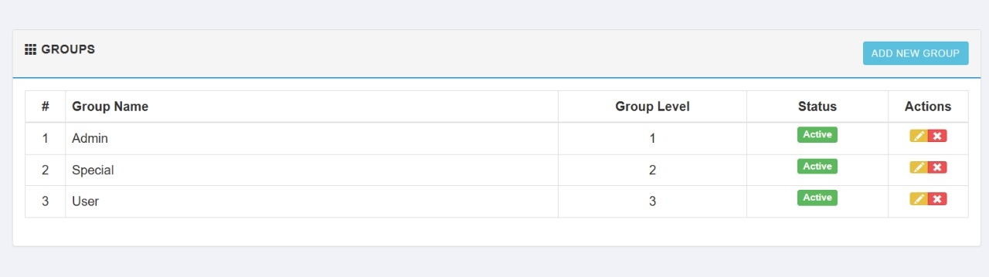

Fig 4.5: User Management- manage groups

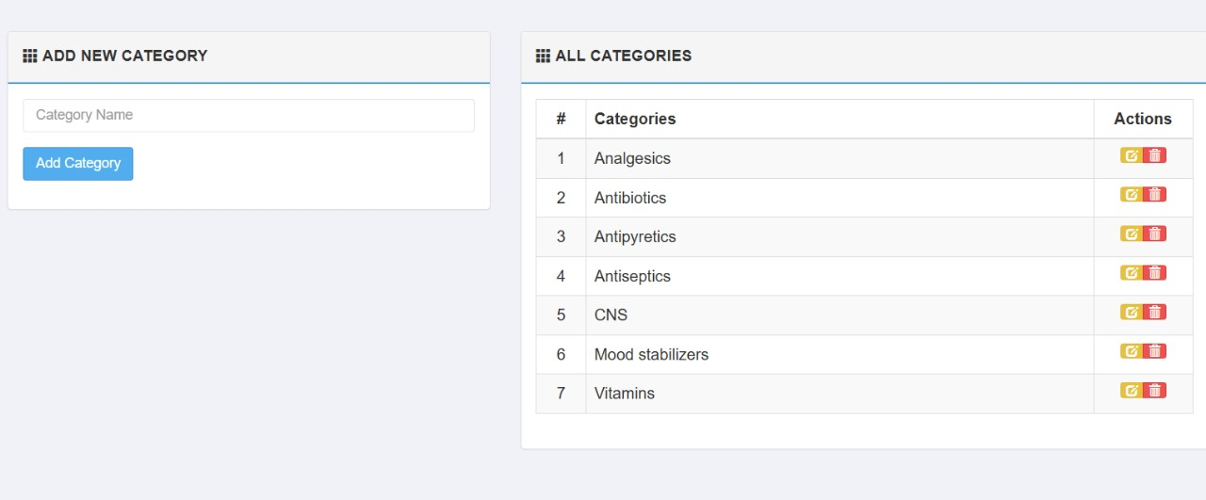

Fig 4.6. Category page

Fig 4.7 Products- manage products

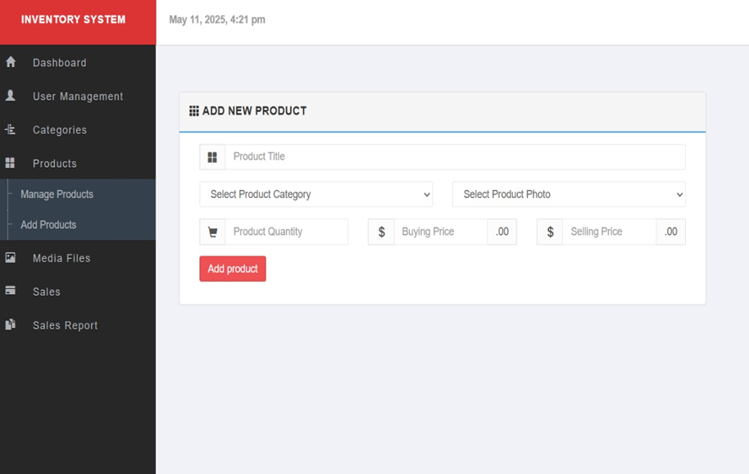

Fig 4.7: Products- Insert new products

Fig 4.8: Media Files

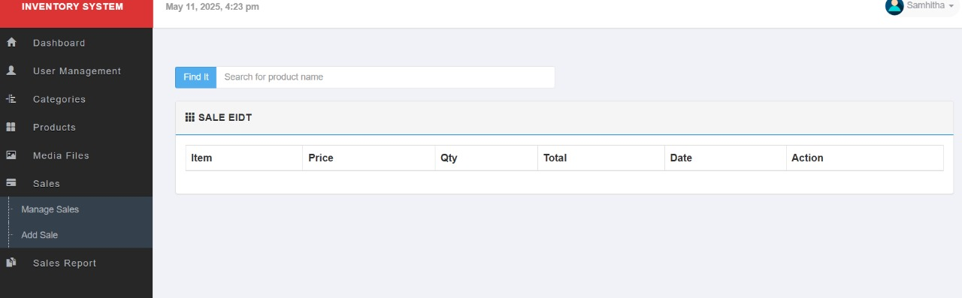

Fig 4.9: Sales- Insert Sales

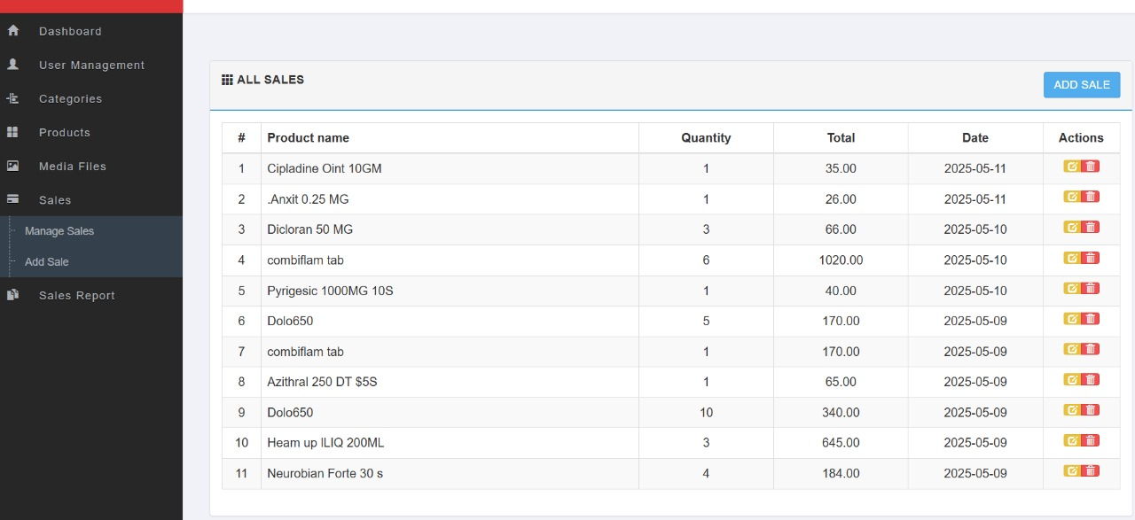

Fig 4.10: Sales – manage sales

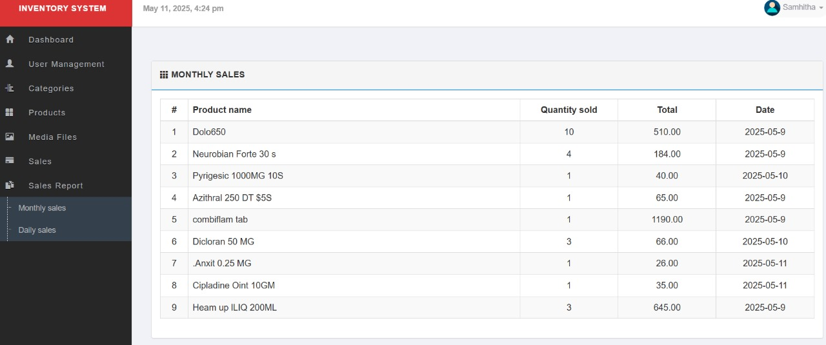

4.11: Sales report – monthly report

**Conclusion**  
The Medicine Inventory Management System provides an efficient and reliable solution for managing pharmaceutical stock. By implementing a web-based interface with CRUD functionality, the system ensures accurate record-keeping, timely updates, and streamlined inventory control. It minimizes human errors, reduces medicine wastage, and supports better decision-making in procurement and supply. Additionally, it enhances accessibility, transparency, and security in managing medical inventories. Overall, this system contributes to improved operational efficiency in pharmacies and healthcare facilities, ensuring that essential medicines are always available when needed, thereby supporting better patient care and resource management.